Introduction May 1, 2026
This lecture introduces the concept of Agentic AI, which refers to AI systems that can act with autonomy, make decisions, and adapt to changing situations by interacting with the real world.
What is Agentic AI?
- Agentic AI has the ability to problem-solve and react to different situations autonomously.
- It can instruct actions, observe outcomes, and adjust its behavior based on feedback.
Example of Agentic AI in Action
- The lecture demonstrates an agentic system where the AI guides a human to cook a dish step-by-step.
- The AI provides instructions, adapts to unexpected changes (like ingredient substitutions), and responds to feedback dynamically.
Human-in-the-Loop Collaboration
- The system relies on a human to perform physical actions while the AI directs and adapts the process.
- This collaboration highlights how agentic AI can work with humans to achieve goals despite limitations in direct physical interaction.
Challenges and Adaptability
- Agentic AI must handle unexpected inputs and adapt plans accordingly, unlike rigid traditional computer systems.
- The AI’s ability to modify instructions based on real-time feedback is key to its agency.
Interfacing with Existing Systems
- Bridging the gap between flexible, adaptive AI communication and rigid computer systems is a challenge.
- Prompt engineering is important to ensure AI instructions can be effectively executed by software or humans.
Overall, the lecture builds intuition about agentic AI’s core capability: to choose actions, request their execution, and adapt based on results, enabling more autonomous and interactive AI systems.

Flipped Interaction Pattern May 1, 2026
This lecture explains the foundational concept of agentic AI systems, focusing on how generative AI can interact in a flipped pattern where the AI asks questions and takes actions to achieve a goal.
Flipped Interaction Pattern
- Instead of humans directing every step, the AI agent asks questions one at a time to gather information needed to complete a task, such as recommending a restaurant.
- This step-by-step questioning allows the AI to adapt dynamically based on user responses, creating a fluid and interactive experience.
Agentic Behavior and Adaptation
- The AI adapts its next question or action based on previous answers or outcomes, demonstrating agentic behavior by choosing and executing steps autonomously.
- It can handle diverse input formats from humans and translate goals into commands for other computer systems, like databases, using its language translation capabilities.
Practical Example and Benefits
- The example of choosing a restaurant in Nashville shows how the AI refines its recommendations by asking about cuisine, dietary preferences, location, and other factors.
- This approach enables AI agents to solve real-world problems by interacting with humans and computer systems, making decisions and adjusting plans as needed.
The Agent Loop May 1, 2026
This lecture explains how to transform a simple conversation with an AI into an autonomous AI agent by creating an agent loop.
Agent Loop Concept
- An agent loop allows the AI to take actions, receive feedback, and adapt its behavior without constant human input.
- The loop involves prompting the AI, interpreting its response as an action, executing that action on a computer system, and feeding back the results to the AI.
From Conversation to Autonomous Agent
- Instead of manually entering commands, the human or a process initiates a task for the agent.
- The agent translates natural language goals into computational actions, such as API calls or file operations.
- The agent can adapt to unexpected situations, like missing data, by adjusting its actions dynamically.
Details of the Agent Loop
- The loop starts with constructing a prompt that guides the AI’s decisions.
- The AI generates a response indicating the next action.
- The system parses this response to identify the action and executes it.
- Feedback from the action is incorporated into the next prompt iteration.
- This cycle continues until the task is complete or terminated.
Importance of Prompt Engineering and Parsing
- Crafting effective prompts is critical to guide the agent’s behavior.
- Responses must be formatted so they can be reliably parsed by traditional software.
- This architecture forms the foundation for building robust, autonomous AI agents.
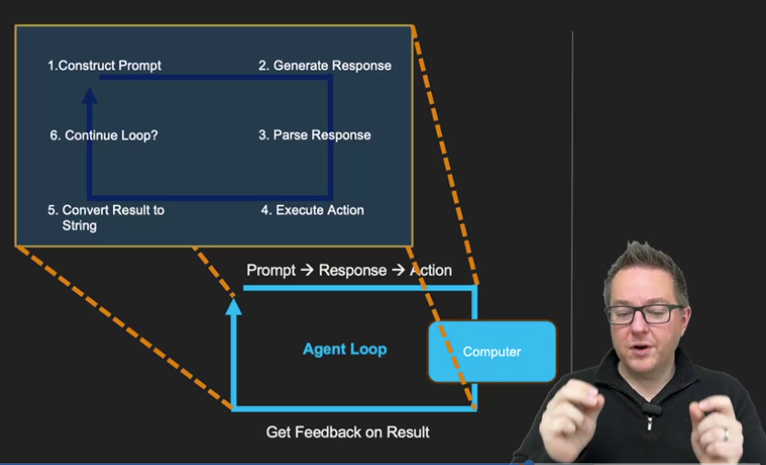

This course on Agentic AI is the perfect bridge between your GKE infrastructure skills and building high-level automation. In an agentic system, the AI isn't just a chatbot; it is a "reasoning engine" that interacts with an environment (like your Kubernetes cluster or a database) to achieve a goal.
Here are the answers for your Knowledge Check:

Question 1: How Agentic AI Operates
Correct Answer: An AI system proposes actions, receives feedback from the environment, and adjusts its next steps accordingly
Standard AI (like a simple LLM) is often "one-shot"—it gives an answer and stops. Agentic AI is iterative. It thinks, acts, looks at the result (feedback), and then thinks again. This is what makes it "agentic"—it has agency to navigate a process.

Question 2: Advantage of Flipped Interaction (Progressive Context)
Correct Answer: It allows the AI to gather context progressively and refine its decision based on user input
This is the Flipped Interaction Pattern. Instead of the user providing a massive, perfect prompt at the start, the AI takes the lead. By asking clarifying questions one by one, the AI ensures it has all the necessary "variables" before it executes a final action, leading to much higher accuracy and user satisfaction.

Question 3: The Agent Loop Sequence
Correct Answer: A task is given → the AI translates it into actions → the system executes them → the AI receives feedback and adjusts its plan → the cycle repeats
This is the core "heartbeat" of an agent. It follows the ReAct (Reason + Act) pattern:
- Plan/Reason: What do I need to do?
- Act: Execute a tool (like a Python script or a SQL query).
- Observe: What happened? Did the tool work?
- Adjust: Based on that result, what is my new plan?

Venkatesh's Pro-Tip for "Programmatic Prompting":
As you move into the coding samples, remember that "Programmatic Prompting" is just a fancy way of saying we are using code to wrap the AI.
For example, in Python, you might use a while loop that keeps the agent running until a specific "final answer" tag is detected. Since you’re studying GKE, imagine an agentic loop where the AI detects a pod failure (Observation), decides to check the logs (Action), realizes there's an OOMKill (Feedback), and decides to update the deployment memory limits (Adjusted Plan). That is Agentic AI in action!
You have until May 2nd to finish this. Are you finding the Python code samples easy to run, or are you hitting any environment issues?

Adding Structure to AI Agent Outputs May 4, 2026
This lecture focuses on how to get generative AI models to output actions in a consistent, programmatically understandable format so that these actions can be executed autonomously by software agents.
Prompt Engineering and Parsing
- Generative AI models produce varied, chatty responses, so prompts must be engineered to produce outputs in a strict, consistent format that can be parsed.
- A common approach is to design a template for the model's output (e.g., "action: object") and instruct the model to follow it, enabling reliable extraction of actions.
Agent Loop and Feedback
- The agent operates in a loop: it outputs an action, the system executes it and provides feedback, which is then fed back into the prompt for the next iteration.
- This loop simulates memory by including the conversation history in each prompt since the model itself has no persistent memory.
Examples of Prompting for Actions
- Simple action templates can instruct the model to pick up objects or perform tasks step-by-step.
- More complex prompts can include placeholders for reasoning and allow the model to output pseudo-code or function calls with parameters, making it easier to parse and execute programmatically.
Function Calling in LLMs
- A second approach, discussed later in the course, involves using LLMs that support function calling, which return structured JSON indicating which function to call and with what arguments.
- This method simplifies parsing by providing a consistent output format but requires LLMs with this capability and may not always be suitable.
Overall, the lecture teaches how to design prompts and parse model outputs to build autonomous AI agents that can decide and execute actions reliably in a programmatic environment.
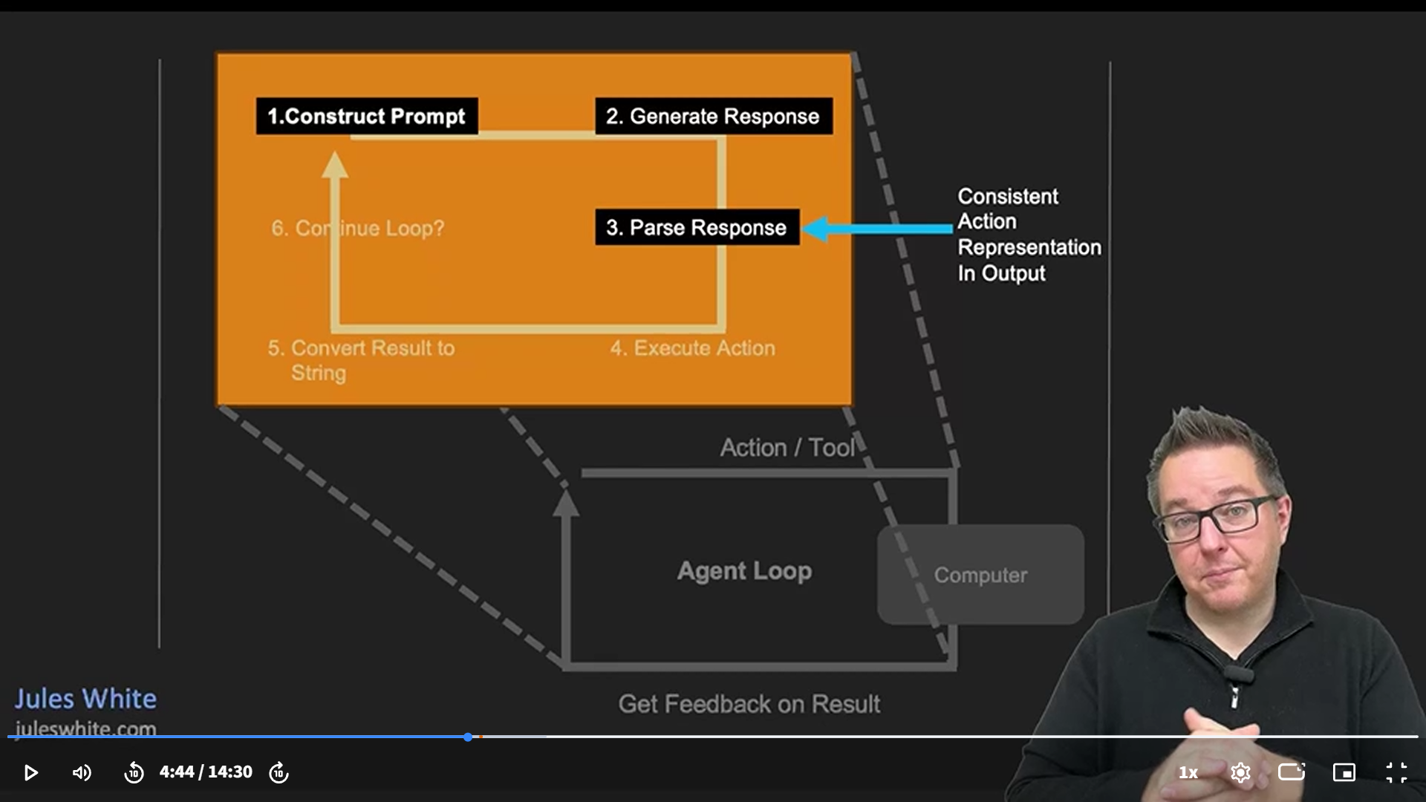

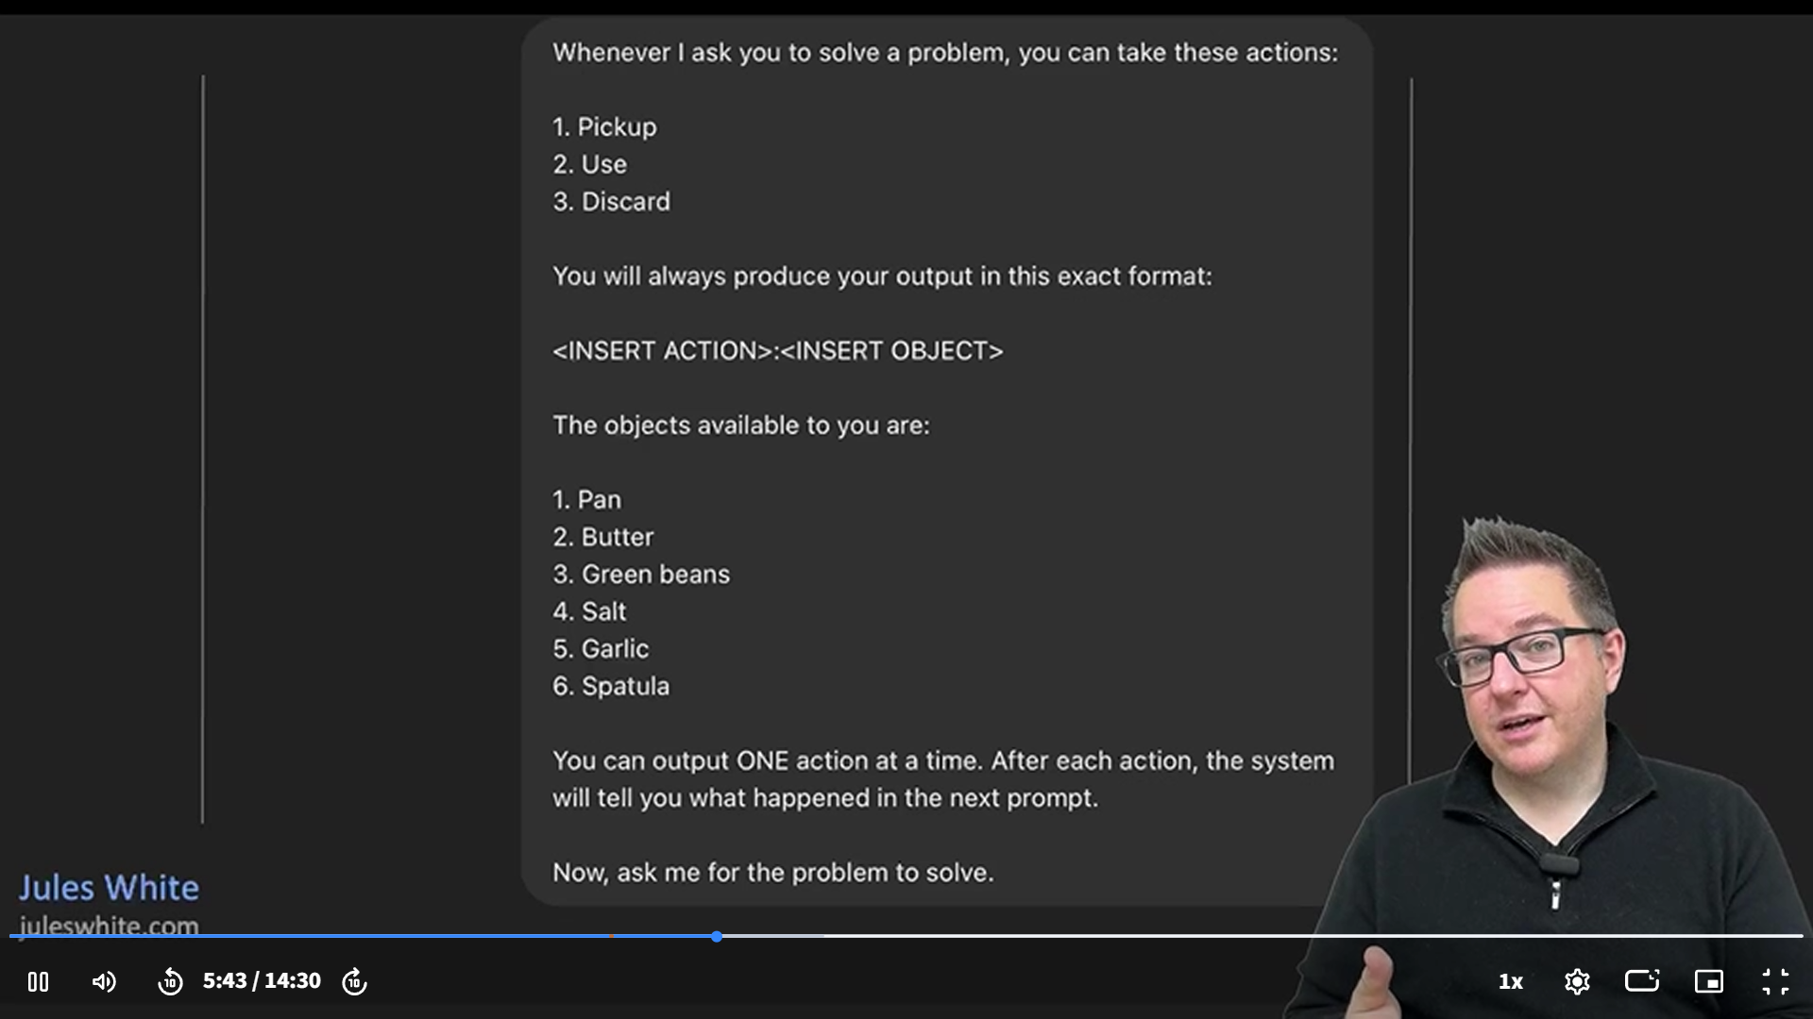

Adding Structure to AI Agent Outputs May 4, 2026
This lecture focuses on how to get generative AI models to output actions in a consistent, programmatically understandable format so that these actions can be executed autonomously by software agents.
Prompt Engineering and Parsing
- Generative AI models produce varied, chatty responses, so prompts must be engineered to produce outputs in a strict, consistent format that can be parsed.
- A common approach is to design a template for the model's output (e.g., "action: object") and instruct the model to follow it, enabling reliable extraction of actions.
Agent Loop and Feedback
- The agent operates in a loop: it outputs an action, the system executes it and provides feedback, which is then fed back into the prompt for the next iteration.
- This loop simulates memory by including the conversation history in each prompt since the model itself has no persistent memory.
Examples of Prompting for Actions
- Simple action templates can instruct the model to pick up objects or perform tasks step-by-step.
- More complex prompts can include placeholders for reasoning and allow the model to output pseudo-code or function calls with parameters, making it easier to parse and execute programmatically.
Function Calling in LLMs
- A second approach, discussed later in the course, involves using LLMs that support function calling, which return structured JSON indicating which function to call and with what arguments.
- This method simplifies parsing by providing a consistent output format but requires LLMs with this capability and may not always be suitable.
Overall, the lecture teaches how to design prompts and parse model outputs to build autonomous AI agents that can decide and execute actions reliably in a programmatic environment.
Venkatesh, this Graded Assignment covers the fundamental mechanics of building AI Agents. Since you've been working with "Programmatic Prompting," these questions focus on how we use code to handle memory, tool outputs, and structured data.
Here are the correct answers and the technical reasoning:

Question 1: Fixing Inconsistent Decisions (Memory)
Correct Answer: Include previous user and assistant messages, including past actions, in the prompt for each new interaction
Technical Reasoning: LLMs are "stateless," meaning they don't remember the previous line of code they wrote unless you send it back to them. To make an agent consistent, you must maintain a "chat history" that includes not just what the user said, but what the Assistant (the Agent) did and the results it saw.

Question 2: Improving Quality for Complex Tasks
Correct Answer: Prompt Chaining
Technical Reasoning: Asking an LLM to do three distinct, complex things in one prompt often leads to "hallucinations" or skipped steps. Prompt Chaining breaks the task down:
- Prompt 1 generates code.
- Prompt 2 takes that code and writes documentation.
- Prompt 3 takes the code and writes tests.
- This ensures the model focuses 100% of its "attention" on one task at a time.

Question 3: Representing Tool Outputs
Correct Answer: To provide the model with the result as new input so it can decide the next action
Technical Reasoning: When an agent calls a tool (like a weather API), the model doesn't "see" the result automatically. By feeding the tool's output back into the conversation as a "user" (or "tool") message, the model can read that data as new context and say, "Oh, it's raining, so my next action should be to suggest an umbrella."

Question 4: Handling Unstructured Model Responses
Correct Answer: Constrain the model to produce responses in a consistent, structured format that can be parsed into actions
Technical Reasoning: Code cannot easily read a paragraph of text to find an API key. By forcing the model to output in JSON or a specific tag format (e.g., [ACTION: API_CALL]), your Python script can use json.loads() to reliably trigger the next part of your code.

Question 5: Defining Model Behavior
Correct Answer: System message, because it establishes instructions that guide how the model responds throughout the interaction
Technical Reasoning: The System Message is the "DNA" of your agent. It tells the model: "You are a helpful assistant," "Only output JSON," or "Never reveal your internal password." It sets the boundaries before the user ever sends their first request.

Final Pro-Tip for your Agentic AI Journey:
When you run the Gemini code we just wrote, notice how we used:
- messages = [{"role": "system", ...}]
- This is exactly what Question 5 is referring to! You are defining the agent's "persona" programmatically.
You're all set to submit this assignment and finish the course. Great work! Any other parts of the agent loop you want to dive into?
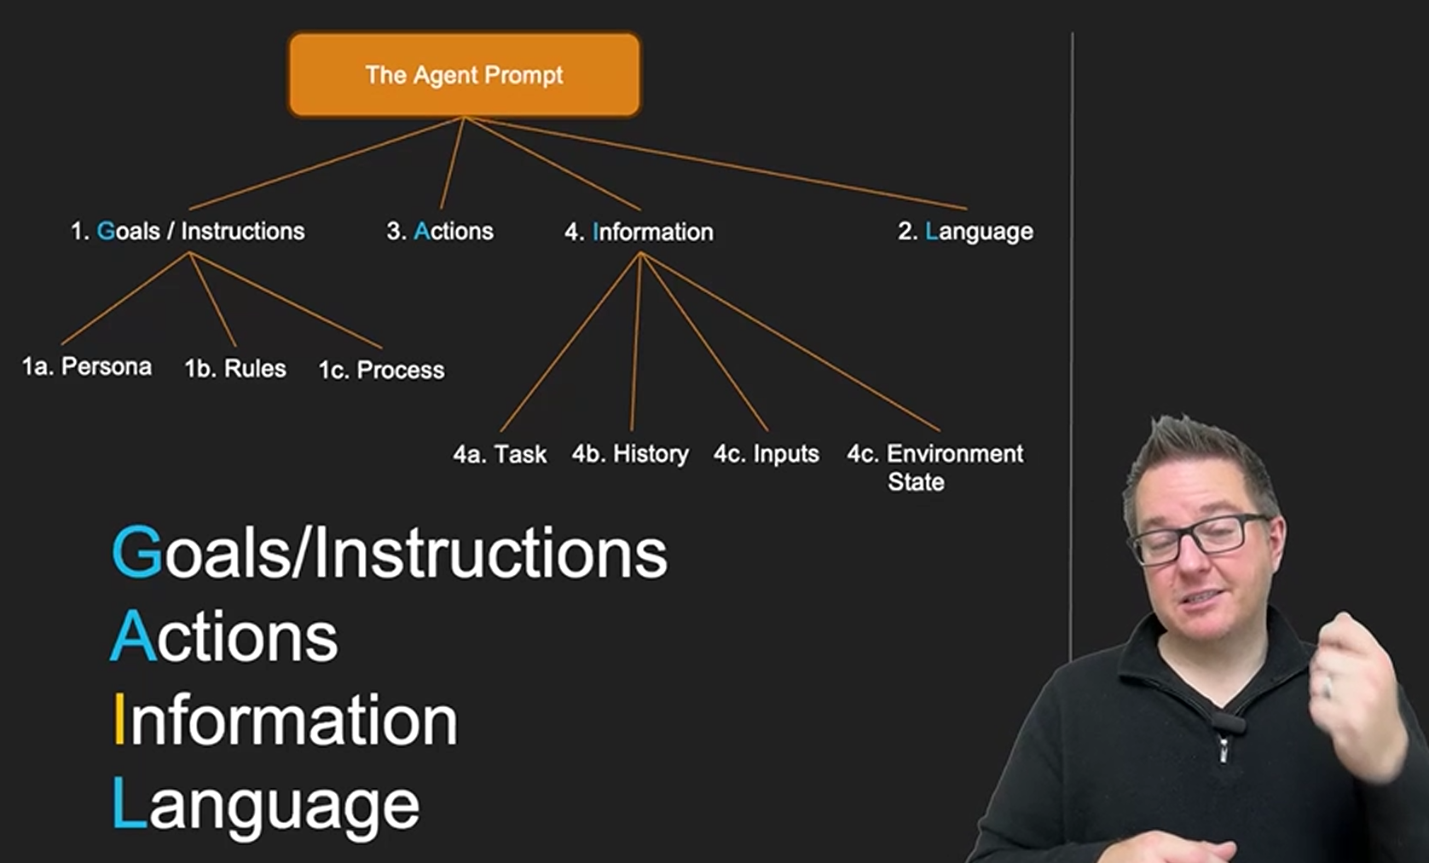

GAIL - Goals, Actions, Information, Language May 6, 2026
This course lecture explains how to construct effective prompts for AI agents by using a structured framework called GAIL, which stands for Goals, Actions, Information, and Language.
Prompt Construction Framework (GAIL)
- Goals/Instructions: Define the agent’s persona, objectives, and processes it must follow to complete tasks correctly.
- Actions: Specify the set of tools or operations the agent can perform to interact with its environment or system.
Information and Language Components
- Information: Provide the agent with necessary input data and ongoing feedback from its actions to guide decision-making.
- Language: Define how the agent should communicate results and interact with users, including output formats and communication style.
Agent Prompt Structure and Messaging
- System messages convey the G, A, and L parts as ground rules the agent always follows.
- User messages provide task-specific information and feedback.
- The prompt guides the agent to think step-by-step, choose actions, and communicate clearly to successfully complete tasks.
Giving Agents Tools May 6, 2026
This lecture explains how agentic AI systems interact with the world through constrained tools or actions to accomplish tasks effectively.
Agent Interaction with Tools
- Agentic AI uses specific tools or actions to perform tasks rather than acting arbitrarily.
- Constraints on tools ensure the agent solves problems within defined limits, reflecting real-world resource restrictions.
Example: Cooking with Limited Tools
- The agent is given a limited set of cooking tools (e.g., skillet, wood fire) and must guide the user step-by-step to cook a meal.
- The agent adapts its instructions based on the available tools, demonstrating problem-solving within constraints.
Tool vs. Action Concept
- Tools are often used when interacting with humans, allowing flexible interpretation of tasks.
- Actions are more explicit and suited for rigid computer systems with limited operations.
- Choosing between tools or actions depends on the context and system being controlled.
Importance of Constraints in Agentic AI
- Real-world systems have limited capabilities, so agents must be bounded by what actions or tools they can use.
- This prevents agents from attempting impossible or unauthorized operations, ensuring safe and practical AI behavior.
Tool Descriptions and Naming May 6, 2026
This lecture focuses on the importance of clearly describing and naming tools when building agentic AI systems, especially when these tools are custom or unfamiliar.
Describing Tool Capabilities
- Agentic AI needs detailed descriptions of what each tool does, not just the tool's name, to understand how to use them effectively.
- Example: Alien spaceship tools with arbitrary names are explained with their functions to guide the AI in using them step-by-step.
The Role of Tool Naming
- Good, descriptive tool names help AI understand and use tools more intuitively.
- Poor or abbreviated names without descriptions can confuse the AI, leading to incorrect assumptions about tool functions.
Context and Usage Instructions
- Providing context about how tools should be used, whether all tools must be used or only some, and the environment helps improve AI decision-making.
- Missing contextual information can cause the AI to make incorrect or irrelevant tool usage choices.
Overall, the lecture emphasizes that both naming and detailed descriptions of tools are critical for effective agentic AI performance, especially when interfacing with complex or custom systems.
Tool Results and Agent Feedback May 6, 2026
This lecture explains a critical step in building agentic AI systems: providing feedback on the outcomes of actions performed by the AI using tools.
Feedback Loop for Agent Actions
- The AI agent proposes an action to perform, which is executed by a human or system.
- The result of that action is then fed back to the agent as the next prompt, allowing it to adapt and decide the next step.
Tool Naming and Interaction
- Tools (or actions) are named similarly to programming functions to align with real computer system interfaces.
- The agent uses these tools step-by-step, receiving detailed results or error messages to understand the system state.
Importance of Clear Feedback and Error Messages
- Feedback includes success results and error messages that explain why an action failed.
- Clear, informative error messages are crucial for the agent to recover from mistakes and make correct decisions.
Example: Cooking with a Microwave
- The agent uses tools like "insert food," "increase time," "start," and "close door" to reheat a quesadilla.
- Each tool's result is communicated back, enabling the agent to adjust its plan dynamically.
Overall, the lecture emphasizes how replacing human feedback with precise tool outcomes and well-designed error messages is essential for effective agentic AI systems that interact with real-world environments.
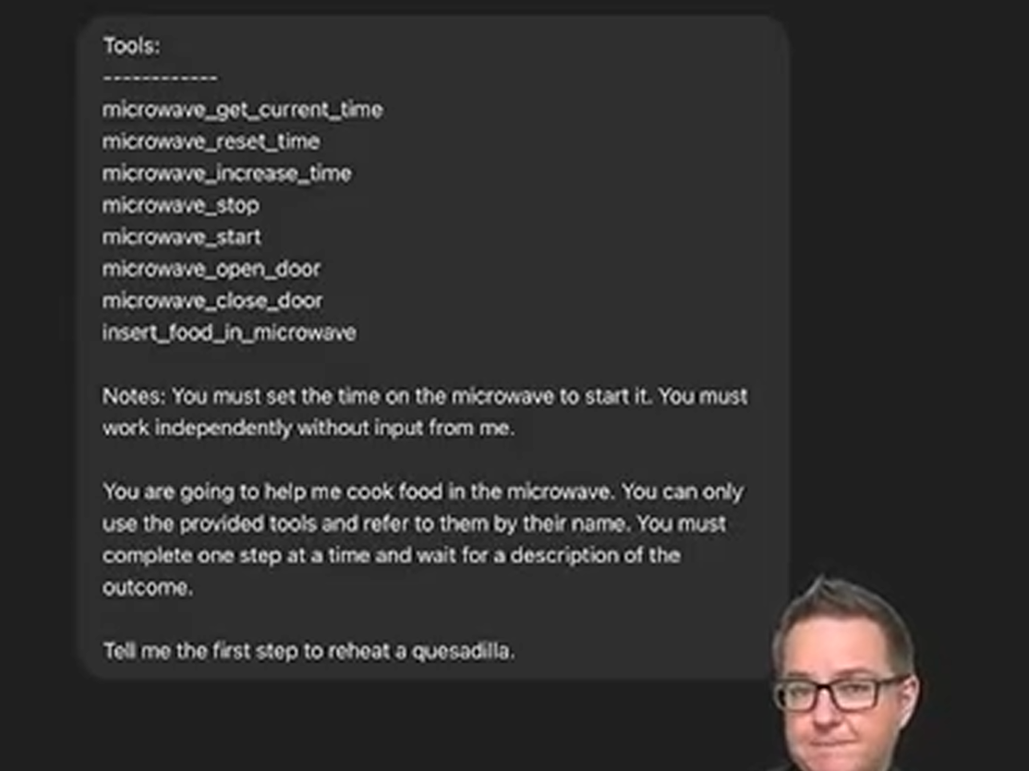

In the context of agentic AI, an Agent Loop is the iterative reasoning process that allows a large language model (LLM) to move beyond single-turn responses and function as an autonomous problem-solver. Unlike a standard chatbot that provides a one-time answer to a prompt, an agent operating in a loop follows a continuous cycle of "Plan, Act, and Observe." This loop enables the system to break down a complex goal into smaller, manageable sub-tasks, executing them one by one while adjusting its strategy based on the results it receives from the real world.
The loop typically begins with Perception and Planning, where the agent analyzes a user's high-level request and determines the necessary steps to achieve it. Once a plan is formed, the agent enters the Action phase, where it interacts with its environment—this might involve executing Python code, searching the web, or calling an external API. The most critical part of the loop, however, is Observation and Reflection. After an action is taken, the agent receives feedback (such as an error message from a terminal or data from a database) and incorporates that information back into its context window.
This recursive nature allows the agent to self-correct and handle ambiguity. If an agent tries to access a file and discovers it is missing, the loop doesn't simply crash; the agent "sees" the failure in the next iteration of the loop and can choose an alternative path, such as searching a different directory or asking the user for clarification. By maintaining this cycle, agentic AI can handle long-running workflows that require multi-step reasoning, memory of past attempts, and the ability to verify its own work before presenting a final solution.
Overview of the GAME Framework May 6, 2026
This course content explains the fundamental structure and design principles of AI agents through the concept of an agent loop.
Agent Loop Fundamentals
- The agent loop continuously executes until a task is completed by deciding the next action based on given goals or instructions.
- Each action is executed in an environment, and the results are stored in memory to inform future decisions.
Core Components of an AI Agent
- Goals or instructions define what the agent is trying to achieve.
- Actions are the possible operations the agent can perform to meet its goals.
- Memory stores the outcomes of past actions to provide context.
- The environment is where actions are executed, which can vary from local processes to cloud services or APIs.
Design Flexibility and Reusability
- The same agent can operate in different environments by changing how actions are implemented without altering the core goals or memory.
- Goals can be adjusted to change agent behavior, such as automatically scheduling meetings versus informing users of options.
Practical Advice for Agent Development
- Use these four abstractions (Goals, Actions, Memory, Environment) as a framework for designing and coding agents.
- Rapid prototyping through interactive conversations (e.g., with ChatGPT) helps refine tool naming and agent behavior before coding.

Simulating Agents in ChatGPT May 8, 2026
This lecture focuses on the challenges and strategies for designing AI agents, emphasizing rapid prototyping through conversational simulation.
Challenges in AI Agent Design
- Designing the agent's instructions, tools, and information format is more difficult than coding the implementation.
- Key design elements include defining goals, actions, and how the agent interacts with its environment.
Rapid Prototyping via Conversation Simulation
- Simulating the agent's behavior through a conversation (e.g., using ChatGPT) allows quick iteration without coding.
- The human acts as the environment, providing simulated outputs and injecting errors to test robustness.
Iterative Design Improvements
- Simulation helps identify design flaws such as missing inputs or ambiguous goals.
- The agent's prompt and toolset can be updated rapidly to fix issues before actual implementation.
- This approach enables testing agent reasoning, handling of different scenarios, and conversation length limits efficiently.

Build the Impossible with AI Agents May 18, 2026
This course content emphasizes innovative thinking in building AI agents, focusing on solving problems that were previously impossible without generative AI.
Innovative Problem Solving with AI Agents
- Avoid building AI solutions for problems already well-solved without generative AI.
- Focus on problems that are currently intractable and require creative AI approaches.
Expanding Input Modalities for AI
- Rethink traditional rigid inputs and explore richer inputs like photographs, conversations, and audio.
- Utilize large language models (LLMs) to handle diverse and complex input types.
Future of Computing with Generative AI
- Understand how generative AI transforms computing paradigms.
- Explore new possibilities for building extraordinary AI agents using generative AI tools and techniques.
Rethinking How We Teach Innovation May 18, 2026
This lecture explains how the future of software development is changing with generative AI, enabling users to build applications more easily and effectively.
Traditional Software Development Challenges
- Conventional software development involves hiring developers who spend long periods building applications that may not meet user needs.
- Often, organizations use licensed software designed for others, leading to mismatches between software capabilities and actual requirements.
Generative AI Transforming Application Building
- Generative AI allows users to create software by simply providing policies or instructions, as shown with an example of travel expense auditing using ChatGPT.
- This approach drastically reduces development time and complexity compared to traditional engineering efforts.
Empowering Users to Build Custom Solutions
- Users without programming expertise, like the example of the son building an inventory management system with just a few prompts, can now create sophisticated applications.
- This shift requires retraining people to think computationally and leverage AI tools to solve problems and build software independently.
Hallucination is a New Form of Computing May 18, 2026
This lecture explores the transformative capabilities of generative AI, particularly focusing on its original strength in language translation and its novel computational ability called "hallucination."
Translation and Creativity in AI
- Generative AI models excel at translation tasks, even creating and translating into entirely imagined languages, demonstrating a new level of creativity and computational power.
- This ability to invent and translate complex concepts into novel forms challenges traditional notions of translation and expands what computers can achieve.
Hallucination as a New Computation
- Hallucination, often seen as a flaw, is reframed here as a valuable new form of computation that enables AI to generate creative solutions and ideas.
- Practical examples include generating unique dinner recipes from limited ingredients and proposing multiple ways to solve problems, encouraging learning through diverse perspectives.
Applications and Implications
- Using AI to generate multiple perspectives helps overcome human biases like confirmation bias by presenting conflicting interpretations for deeper analysis.
- AI can enhance human collaboration by identifying ambiguities in communication, prompting further discussion and improving understanding, rather than just summarizing information.
New Ways to Access and Extract Information May 18, 2026
This course content explains how generative AI is transforming the way we think about and interact with data.
Rethinking Data Interaction
- Traditional computing required structured, well-formatted data to produce results, focusing heavily on data management and curation.
- Generative AI is more flexible, able to extract and fuse data from diverse formats, including unstructured sources like images.
Practical Examples of Generative AI Data Use
- A picture of a catering menu was used to generate a lunch order without needing a structured database.
- A photo of a coffee maker was used to get step-by-step usage instructions, bypassing the need for manual searches in user manuals.
Implications for Future Computing
- Data can now be accessed contextually and on demand, anywhere and anytime, changing how we query and use information.
- This new approach to data interaction resembles instant knowledge transfer, enabling problem-solving in novel and efficient ways.

